Lexical Semantic Edge Context Injection Improves Graph Representation Learning at Low Cost
Marcello DeLuca¹, Sahil Kapadia¹, Kushal Koirala¹, Christopher Bizon², Alexander Tropsha^{1*}

- Division of Chemical Biology and Medicinal Chemistry, Eshelman School of Pharmacy, University of North Carolina at Chapel Hill, Chapel Hill, NC 27599
- Renaissance Computing Institute at UNC Chapel Hill, Chapel Hill, NC

*email: alex_tropsha@unc.edu

Contents (for editing / internal use)
Abstract
Introduction
Results
- Convert edges & edge features to natural language for LLM featurization
- LLM featurization of natural language
- EdgeAggregator (message passing w/ LLM features for edges only (low-leakage))
- EdgeNodeFeatureAggregator (message passing w/ LLM features for edges & nodes)
- GraphSAGE Edge Software (input kg; specify qualifier level as “all-edge”, “all-node”, “name” or list[feature] to use as inputs; select loss function;) -> dict{ID -> vector mappings}
- Benchmarking:
  - Other Graph Methods
    - Node2Vec
    - GCN
    - GraphSAGE regular version unsuervised
  - Supervised / integrated representation + ML
HGT
  - Datasets
    - Some standard dataset with multiple relation types like FB15k-237
    - Drug discovery specific dataset like PrimeKG
  - Benchmark Performance
    - Graph Completion (withhold edges and predict)
      - Look at what GraphSAGE did and what HGT did etc; compare to these methods directly, make sure we have small and large datasets and optimize hyperpara
      - meters using optuna or similar
      - Node-split evaluation against GraphSAGE & HGT etc.

    - MATRIX-style predictions?
Discussion & Conclusion
- Simple, low-cost method that improves performance
- Flexibility to further contextualize with words around the edge like “edge in a biomedical knowledge graph with the following properties: […]”.

Methods
References
Supplemental Information

Abstract. Graph representation learning forms the bedrock of much of the world’s economy, but most methods lack rich representations of edges d their qualifiers which could be used to improve performance. Existing methods must learn a new set of parameters for each edge type, a constraint which is restrictive for graphs with many edge types, dilutes learning, and often does not learn differential edge meanings between related edge types. We introduce GraphSAGE-edge, a message passing machine learning method which injects lexical semantics of edge context into the GraphSAGE paradigm. GraphSAGE-edge adds rich edge context and the meaning of interrelated edges via LLM inference of the edge and qualifiers at the cost of a single LLM call per edge type. Performance improves significantly across all graph types and learning tasks, achieving SoTA in XXX. It can be dropped directly into any system currently using graph representations for downstream ML tasks. GraphSAGE-edge is offered as an open-source package and free LLM credit allocations (e.g., Google Gemini free tier) are sufficient to implement the full method.

Introduction. Graph representation learning has been applied broadly across advertising and marketing, drug discovery, social networks, and more. More often than not, methods considering only graph topology (e.g., Node2Vec, GraphSAGE) are used to featurize nodes for downstream ML. Methods which do use edges often apply simple scalar weights to each edge type, and methods which fully use edge context usually require that a large set of weights is learned for each edge type (e.g., ConvE, TransE, RotatE, Heterogeneous Graph transformers (HGTs)). This means that for graphs with hundreds of edge types, datacenter-scale resources are required for effective weight learning. Furthermore, each qualifier (edge property) added to the edge combinatorically increases the number of edges and dilutes learning. Lastly, methods like HGT are data-hungry, and many applications will never contain sufficient training data to train an effective HGT with many edge types. For example, in drug repurposing, only on the order of 10,000 therapeutic indications exist, and new ones are discovered at a rate of only a few per year.
It thus appears that there is a need for graph-based ML methods which add value using edges at significantly lower cost relative to expensive per-edge weight learning and which are usable in models that perform better on smaller datasets like vanilla multilayer perceptron (MLP) or RF/ XGBoost methods.

The advancement of large language models (LLMs), which learn lexical semantic meaning from large corpuses of text, means that it is now trivial to convert the lexical semantic meaning of a word or passage into a feature vector using a simple API call. To the best of our knowledge, these have not been used to add low-cost context to

GraphSAGE is uniquely well-suited to this since

Table 1: overview of existing edge-aware methods
Method | Description | Scoring | Citation | Year | Limitations
TransE | Relation = translation | $$-\left\|h+r-t\right\|$$ | Bordes et al, NeurIPS 2013 | 2013 | No 1-to-N
DistMult | Score = 3-vector inner product | $$\left\langle h,r,t\right\rangle$$ | B Yang et al, arXiv 2015 | 2015 | No antisymmetric or inverse relations
ComplEx | Score = real component of 3-vector inner product, t = | $$Re\left(\left\langle h,r,\overline{t}\right\rangle \right)$$ | Trouillon et al, arXiv 2016 | 2016 | Has antisymmetry & inverse but not compositional
R-GCN | Relation type specific GCN transformations | Encoder layer, DistMult for links | Schlichtkrull et al, arXiv 2017 | 2017 | Size blows up with many edge types
GAT | Neighborhood attention | E2E | Veličković et al, ICLR 2018 | 2018 | Size
RotatE | Relations trained as | $$-\left\|h∘r-t\right\|$$ | Sun et al, ICLR 2019 | 2019 | Composition limited to ~2 hops, imbalance
HGT | Transformer w/ msg passing | E2E loss | Hu et al, arXiv 2020 | 2020 | Way too big (1B+)
GraphSAGE-Edge | GraphSAGE with semantic edge embeddings | Unsupervised or supervised loss | In preparation | 2026? | Not an E2E method

Results.
Lexical Semantic Context Injection

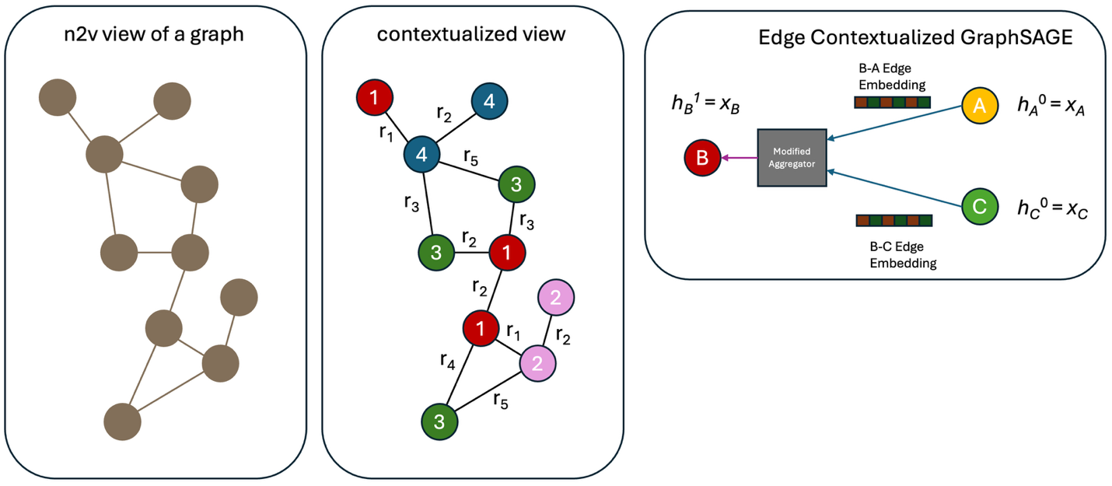
Figure 1: Comparison of edge- and node-agnostic methods to edge- and node-aware methods, and introduction of GraphSAGE-edge

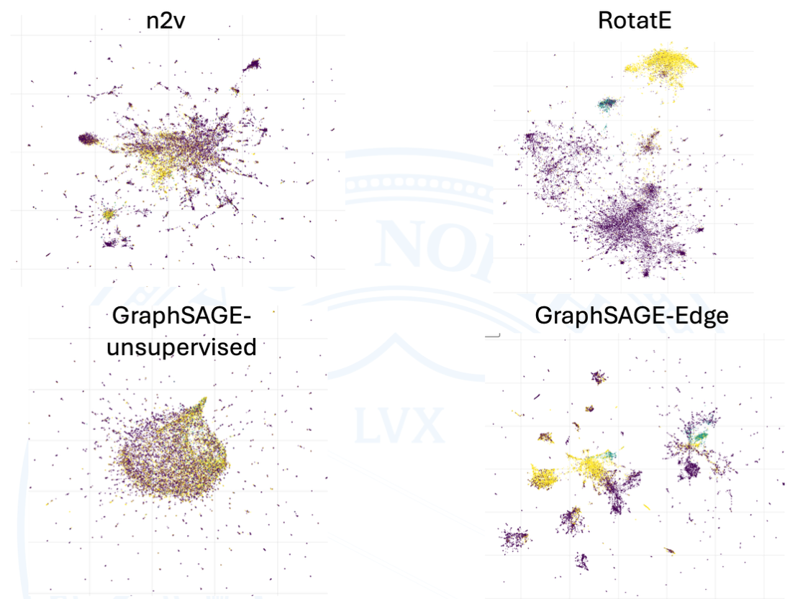
Figure 2: UMAP of different methods, colored by node type showing more clear and rich separation between node types and also well-separated clusters of individual nodes without injecting node type

Table 1: Edge Split Task
Dataset | Method | ROC-AUC | AP | Hits@1 | Hits@3 | Hits@10 | Δ AP vs SAGE
PrimeKG | baseline_sage | 0.906 | 0.244 | 0.347 | 0.737 | 0.970 | —
 | edge_aware_sage | 0.946 | 0.511 | 0.553 | 0.867 | 0.985 | +0.267
 | hgt | 0.962 | 0.365 | — | — | — | +0.121
 | node2vec | 0.958 | 0.651 | 0.757 | 0.901 | 0.981 | +0.407
FB15k-237 | baseline_sage | 0.846 | 0.283 | 0.344 | 0.627 | 0.900 | —
 | edge_aware_sage | 0.895 | 0.382 | 0.452 | 0.745 | 0.950 | +0.099
 | hgt | 0.886 | 0.333 | 0.401 | 0.676 | 0.931 | +0.050
 | node2vec | 0.807 | 0.131 | 0.347 | 0.629 | 0.907 | -0.152

Table 2: Node Split
Dataset | Method | ROC-AUC | AP | Hits@1 | Hits@3 | Hits@10 | Δ AP vs SAGE
PrimeKG | baseline_sage | 0.879 | 0.219 | 0.288 | 0.669 | 0.947 | —
 | edge_aware_sage | 0.938 | 0.473 | 0.487 | 0.829 | 0.975 | +0.254
 | hgt | 0.841 | 0.450 | — | — | — | +0.231
FB15k-237 | baseline_sage | 0.804 | 0.199 | 0.266 | 0.542 | 0.862 | —
 | edge_aware_sage | 0.881 | 0.334 | 0.409 | 0.704 | 0.932 | +0.135
 | hgt | 0.748 | 0.236 | 0.284 | 0.534 | 0.842 | +0.037

Make sure to add all the embedding types into this table, include baseline GCN as well
Loss curves, optimizations, etc. Etc. UMAP etc.

Take training set and take node
Summary for paper writing:

Discussion.

Methods.

